Abstract
A Title of Your Paper Should be Written in 14Pt Times New Roman
Zhexu Zhang¹, Wei Lv²
¹Engineering Laboratory for Functionalized Carbon Materials and Shenzhen Key Laboratory for Graphene-based Materials, Graduate School at Shenzhen, Tsinghua University, Shenzhen 518055, China
²Tsinghua-Berkeley Shenzhen Institute (TBSI), Tsinghua University, Shenzhen 518055, China
Email: graphene@sz.tsinghua.edu.cn

The title of your abstract should be in initial capital letters, not all caps.
The length of the abstract should be around 200 words (no more than 300 words). It should briefly state the purpose, method and results of the paper.
The size of the poster is based on the international standard: 90 cm (width) * 120 cm (height), and the top and bottom margins are 25 mm.
References
[1] Su F.Y., You C.H., He Y.B., Lv W., Yang Q.H., et al. Flexible and planar graphene conductive additives for lithium-ion batteries. Journal of Materials Chemistry, 20, 9644-9650 (2010).

Speakers’ Photograph
The format of the Photograph should be like the sample below. Please be sure to dress appropriately, in business casual attire preferred. The photo with image resolution should be no less than 200k.
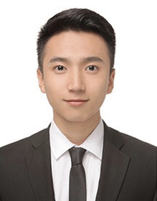

Curriculum Vitae
The length of the Curriculum Vitae should be around 200 words (no more than 300 words). It should briefly state the personal information and main achievements.

